From: mazen@gmail.com
To: name@gmail.com
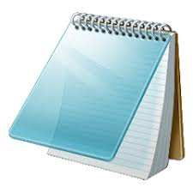
Hello Teacher: Mazen Saad,

I am a student in grade three.
I am writing this e-mail to say thank you for your great effort with us.
I like your class very much and I enjoy learning with you.
Your lessons are easy and fun, and I learn new things every day.
I hope to be a good student and make you happy.

Thank you
Your student
Mohamed

